**Bitgrit Inc., Machine Learning Competition-I**

Manu Kohli

The Problem is approached using following three algorithms

1. Auto encoders > focussed on using data containing expressive feelings such as joy, enjoy feeling, anger and so on.
2. SVM Classifier > friend count, status counts , account count
3. Multinomial Bayes > To confirm the findings and list a spammer

**Challenges:**

The Problem set attributes are derived from sentiment analysis, content analysis and topic modelling. Therefore a single algorithm is not used but multiple algorithms are used to #predict the outliers.

Algorithm description & Attributes Used:

**1) Auto encoder:**

The auto encoder tries to learn a function hW,b(x)≈x. In other words, it is trying to learn an approximation to the identity function, so as to output x^ that is similar to x

Autoencoder finds the low dimensional representation of input data, In our Problem set matrix derived from content analysis include the emotion in the form of Anger, Disgust, Fear, Joy etc. To process the data we needs an algorithm that work real well with low dimensional data.

The following is the model loss for the Auto encoder program

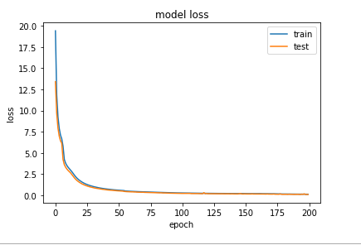

**Number of users Spammed by the Autoencoder 398**

**#2) SVM Classifier:**

The best thing about SVM is working with high dimensional data, In our Problem set statusesCount, followersCount, friendsCount, listedCount, and Account Age needs to be analysed, therefore we need an algorithm that can predict the outliers in high dimension.

We have used following techniques if the user is spamming or not. We have distributed dataset into training and test. On the test dataset (which we are using for Prediction if user is Spamming) , if user is spam then finding the word cloud as a second step and pass that to Auto encoder. We run trained Autoencoder, if the thresholdis above 0.75 then it is assumed that the user is spammer by Autoencoder as well.

In the Same Test Data If we train SVM classifier to detect the outliers on the test data. If the same user is identified as spammer by the both algorithms, then the user is considered as spammer.

**Number of users Spammed by the SVM Classifier 799**

**#3) Multinomial Bayes:**

We have trained Multinomial Bayes Alogorithm on the word used by the user, on Labels (0,1) i.e. 1 for user that is spammed and 0 not by above both algorithms.

In this way Multinomial Bayes algorithm learn that which word a spammed by a user. **Number of users Spammed by the Both Autoencoder & SVM Classifier are 98**

The accuracy of the model is 96.1% with the following confusion matrix

**Confusion matrix:**

**[[961 7]**

**[ 32 0]]**

In the end we have made a cloud of word used by the Spammed User that are confirmed as spammer by both algorithms.

|  |  |  |
| --- | --- | --- |
| **7** | 26 | amp |
| **408** | 17 | god |
| **22** | 14 | get |
| **72** | 12 | will |
| **229** | 12 | bro |
| **174** | 12 | top |
| **37** | 11 | don |
| **406** | 11 | bless |
| **180** | 11 | thank |
| **34** | 10 | can |
| **397** | 10 | NaN |
| **154** | 9 | good |
| **29** | 9 | like |
| **363** | 9 | new |
| **251** | 9 | love |
| **168** | 8 | happy |
| **230** | 8 | birthday |
| **398** | 8 | news |
| **152** | 7 | people |
| **155** | 7 | just |
| **205** | 7 | much |
| **26** | 6 | now |
| **228** | 6 | doubt |
| **166** | 6 | really |
| **299** | 6 | says |
| **359** | 6 | free |
| **178** | 6 | followers |
| **394** | 5 | djzjpwky |
| **395** | 5 | abhorrent |
| **204** | 5 | troph |